User profile


Name: Jeff Buckingham
Age: 22
Occupation: junior software dev

Hobbies: coding challenges, chess tournaments, miniature building(Warhammer)

Backstory: recent college alum, has started working in a not so great paying development job. Travels a lot from Dundalk to Dublin for it. Must use public transport. Lives with two roommates, Charles and Bob. Like a few pints at the weekends. Cooks his own pizza.

Reason for using app: has a lot of old college text books that he doesn’t use as he is learning new coding languages. Would like to supplement his income by loaning them out monthly. Clients could be in either Dundalk or Dublin as he is frequently in both. Doesn’t want to sell them outright as may still need them somewhere down the line.

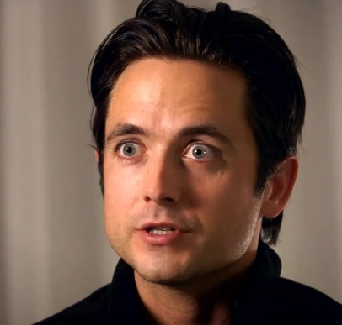

Name: Michael Burns
Age: 43
Occupation/Education: Mature Software Dev. Student, 2nd Year
Hobbies: reading, coding, gardening

Background: Recently laid off from his longterm working position at a construction company, Michael has decided to reaffirm his life and look to IT for work. He has completed one of a three-year course, commutes to college daily, and works parttime at a local newsagents to make ends meet when paying college & travel fees.

Reasons to use app: Short on Cash, Michael would prefer to save where he can. The college library offers a wide array of digital ebooks but he struggles to study off a screen and has an absolute preference on reading an analog copy instead. Is very interested in borrowing books.

